WiN UK Executive Committee
Volunteer Application Form

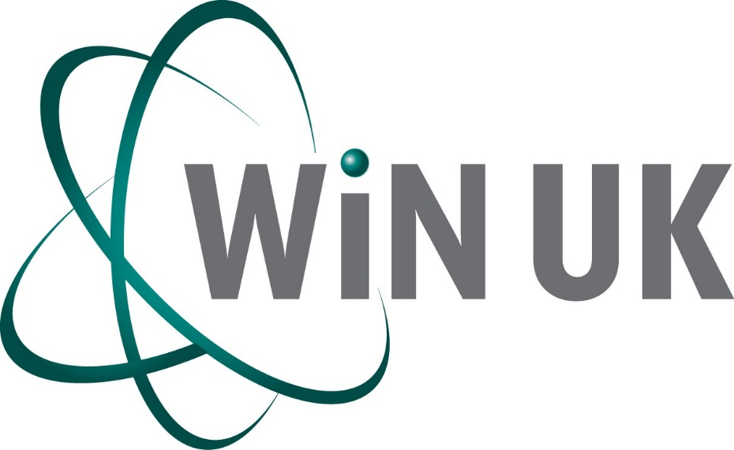

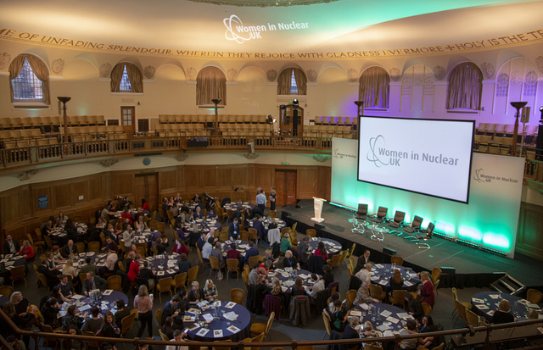

Notes
Inclusion
WiN UK is an inclusive organisation. We don’t just accept difference — we celebrate it as a core value at the heart of our mission. We believe that an inclusive organisation is a successful and happy organisation. We therefore welcome applications from those in under-represented groups, and are committed to ensuring a fair and inclusive selection process for all applicants.
Applications
All applications should be prepared in conjunction with the relevant role profile for the post you are applying for and submitted using the template below. All sections should be answered as fully as possible.
Please, note all personal information in the Section 1 of the form will be blanked out, to allow assessment be based purely on the answers you provide in the Section 2 of the form. Try to avoid putting your name, company or any other identifying elements into your answers for Section 2.
All applications should be submitted by email to:
events@womeninnuclear.org.uk
Process
The closing date for all applications is 16th March 2020.
Applications will be short listed by the end of March 2020.
Interviews are expected to be carried out by the end of April 2020.
Receipt of your application will be acknowledged within 3 working days. If you do not receive an acknowledgement please contact us again to ensure there have been no technical issues with your application arriving safely with us.
Selection
All applications will be evaluated by a WiN Executive Board sub-committee.
All applicants will be informed of the outcome, you will be notified if you have been shortlisted for a role or if you have unfortunately been unsuccessful on this occasion.

We look forward to receiving your application!

WiN UK Executive Committee Application Form
Section 1
Role applied for:
Date of application:
Name:
Current Role:
Company:
Address:
Email address:
Telephone number:

Have you sought approval from your line manager to apply for this role (if employed)?
Have you applied for any other WiN UK roles? If yes, which once?

Date application received (WiN UK to complete):
Applicants number (WiN UK to complete):

Section 2
Role applied for:
Applicants number (WiN UK to complete):

Why would you like to volunteer for WiN UK Committee?

Why would you be suitable for this role?

Using the “Main Responsibilities" section of the role profile as a guide, please outline briefly how you may consider going about this role, when in post?

Are there any other skills or capabilities you have that can support WiN UK in its activities?

